

**Asset Practice Answers: Mathematics**



1.

Shown here is a necklace with 10 beads. It shows 1 ten. Which of these shows 10 tens?



1.  B.





C. **D.**

2. What number comes just after 8 tens and 8 ones?

A. 81

B. 82

**C. 89**

D. 810

3. How many straight lines can be formed by joining any two points in the figure below?

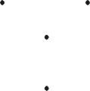

A. 2

B. 3

C. 4

**D. 6**

4. You have to go through the boxes below, ADDING the points in the white boxes and SUBTRACTING

the points in the shaded ones.



How many points will you have at the end?

**A. 20**

B. 35

C. 40

D. 60

5. John was sticking stamps in an album. He can stick 5 stamps in each row as shown.

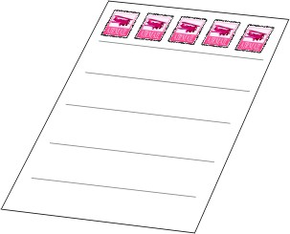

If each page has 6 rows, how many stamps will a page have in all?

A. 5 + 6

B. 6 + 6

C. 5 x 5

**D. 5 x 6**

6. Ravi wants to get the answer to 4 × 8 but does not know his 4 times table. What could he do to get the answer to 4 × 8?

A. 8 + 4

B. 8 × 8 × 8 × 8

**C. 8 + 8 + 8 + 8**

D. 4 + 8

7. Mita first bought 33 chocolates for her son Yash's birthday. Later she thought more friends of Yash would come and she bought 15 more chocolates. Yash gave away 40 of the chocolates his mother bought, to his friends.

How many chocolates remained?

A. 0

B. 7

**C. 8**

D. 25

8. A part of a test paper is shown.

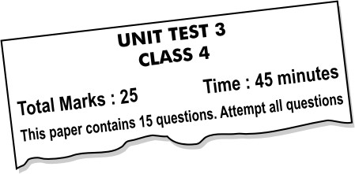

What is the highest score you can get on this test?

A. 15

**B. 25**

C. 40

D. 45

9. Shown here are the total points of four groups in a class quiz..

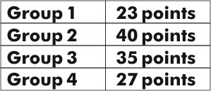

How many points more than Group 4 did Group 2 get?

A. 27

**B. 13**

C. 8

D. 40

10. Mita has kept her doll next to a tower of blocks.

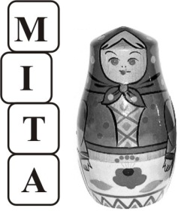

If each block is 10 cm high, about how tall is Mita's doll?

**A. 35 cm**

B. 25 cm

C. 20 cm

D. 10 cm

11. Look carefully at the calendar below:

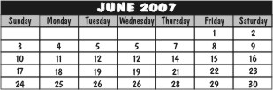

Mihir has a swimming class every Tuesday and tennis coaching every Friday. How many more tennis classes will Mihir have than swimming classes in June?

**A. 1**

B. 2

C. 3

D. Number of tennis classes would be same as the number of swimming classes.

12. One hand of Pinky's clock has fallen off. Now the clock has ONLY THE HOUR HAND. What could be the time when the clock face is as shown below?

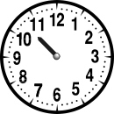

A. 10:00

**B. 10:30**

C. 11:00

D. 11:30



1. D:



So, 2 tens can be shown by two necklaces as



. 10 tens can be shown by 10 necklaces as in D.

2. C: 8 tens = 80 and 8 ones = 8. The number 8 tens and 8 ones is 88. The number that comes just after 88 is 89. Hence C

is the answer.

3. D: You can draw 6 straight lines joining any two points as shown below.

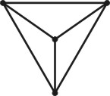

Did you think that you could use a point only once? In fact you can use a point more than once.

4. A: Remember, you have to add the numbers in the white boxes and subtract the numbers in the shaded ones. Let us go through the boxes. First we have to do 20 - 5 = 15. Then subtract 10 in the shaded box. 15 - 10 = 5. Add 5 and 15 in the white boxes. 5 + 5 = 10. Then 10 + 10 = 20. Finally we have to subtract the 5 in the last shaded box. 20 - 5 = 15.

5. D: There are 5 stamps in a row. There are 6 rows in an album. So 6 rows can contain 5 + 5 + 5 + 5 + 5 + 5 stamps. 5 +

5 + 5 + 5 + 5 + 5 = 6 x 5. And 6 x 5 is 30. 5 x 6 is also 30. Hence D is the answer.

6. C: Ravi cannot recall the table of 4 and does not know what 4 eights are. 4 x 8 = 8 + 8 + 8 + 8. So he can add 8 four times to get the answer.

7. C: Mita first bought 33 chocolates and then she bought 15 more. So she bought 33 + 15 = 48 chocolates in all. Of this Yash gave away 40 chocolates. So there are 48 - 40 = 8 chocolates left. You may possibly have done 40 - 15 = 25. That is not what we should do here. Try to understand what the question says before answering it.

8. B: Can you see "Total Marks : 25" on the paper? What does it mean? It means that the paper is for 25 marks, or the highest score you can get on this test is 25. Do you know that score here means marks? The paper says "Time: 45 minutes" It means that you have to solve the paper within 45 minutes. 45 is NOT the maximum score you can get.

9. B: Group 2 got 40 points and Group 4 got 27 points. So Group 2 got 40 - 27 = 13 points MORE than Group 4. Note that the question asks for the number of points that Group 2 got MORE than Group 4, and not the number of points that Group 2 got.

10. A: Can you see that the doll is a little more than 3 blocks tall? Each block is 10 cm. So 3 blocks kept one over the other would be 30 cm high. The doll is slightly more than 3 blocks tall, in fact it almost reaches the middle of the fourth block. So the doll could be 35 cm tall.

11. A: How many Tuesdays are there in June, in the calendar shown? There are 4! ( 5 th, 12 th, 19 thand 26 thof June are Tuesdays.) How many Fridays are there? 5! So Mihir will have 4 swimming classes and 5 tennis coaching classes. So he has 1 more tennis coaching class than swimming class. It is not necessary that there are as many Fridays as there are Tuesdays in a month.

12. B: The hour hand of a clock shows the hour. Have you seen how the hour hand of a clock moves? Does it move

suddenly from 10 to 11? No! It takes one hour to move from 10 to 11. It is at 10 at 10 O'clock. It slowly moves to 11 by 11

O'clock. So at a time between 10 O'clock and 11 O'clock, the hour hand would be between 10 and 11. In the given picture, the hour hand is between 10 and 11, so the time could be 10:30, between 10 O'clock and 11 O'clock.